Fittings for washroom near DOI For M/s Illyas
- Hand Dryer S/S
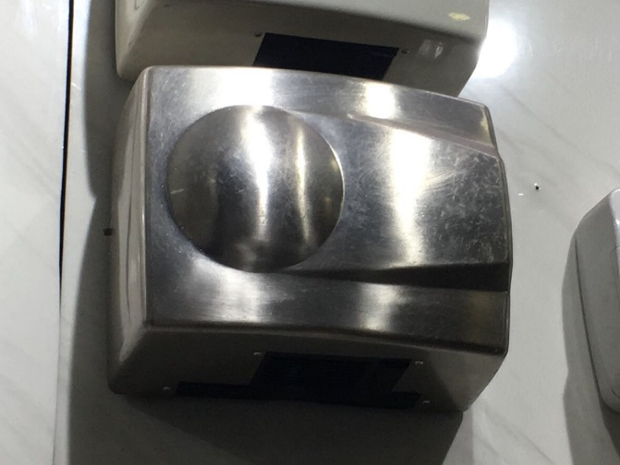

- Paper Holder
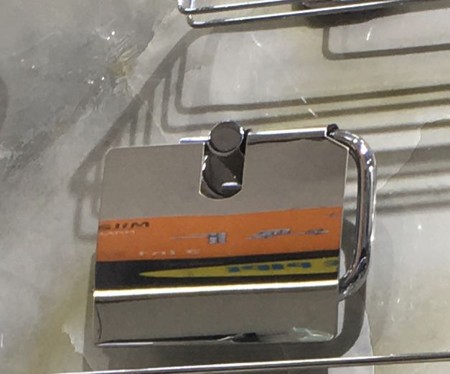

- Soap Dispenser
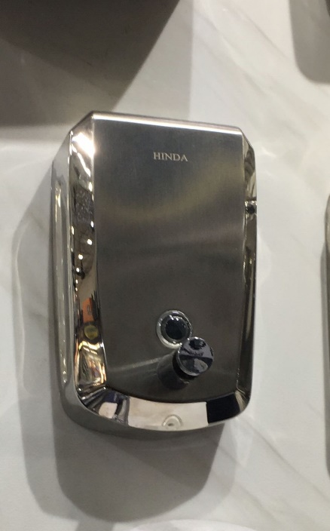

- Urinal Flush Valve (YL5102)
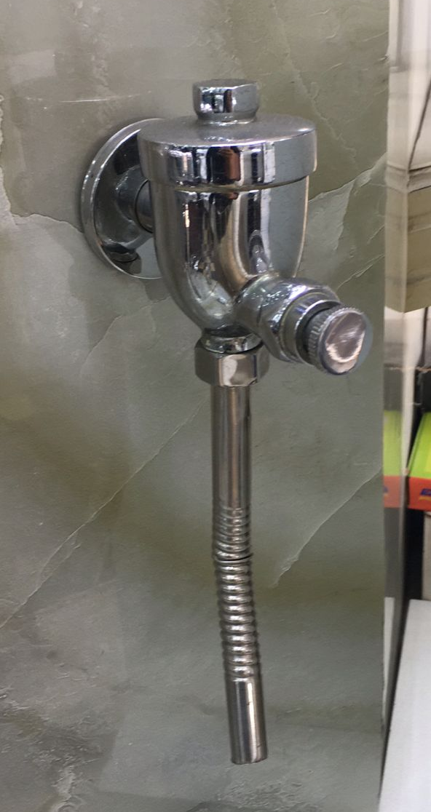

- Bidet Spray
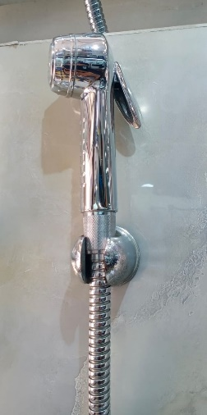

- Squatting Pan
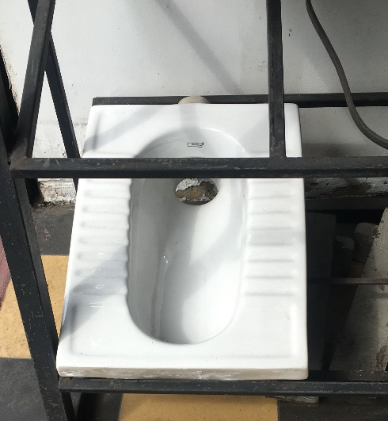

- Plastic Cistern
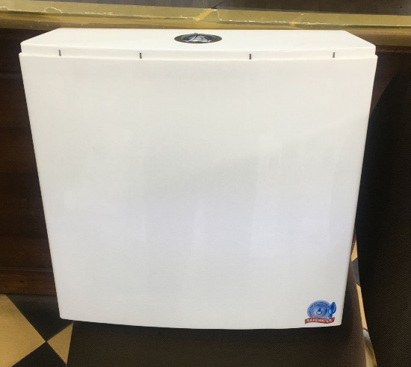

- Shanks Chine Wash Basin – Rs.47,000/=
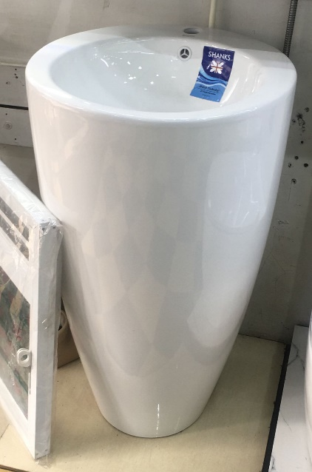

- Soap Basket sq
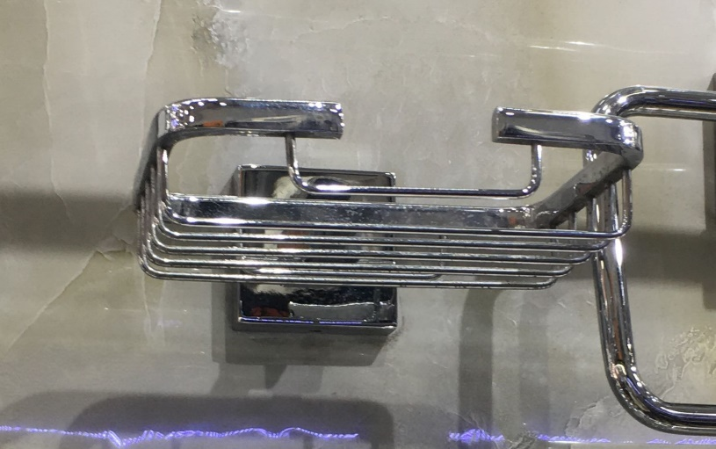

- Plain sq Mirror
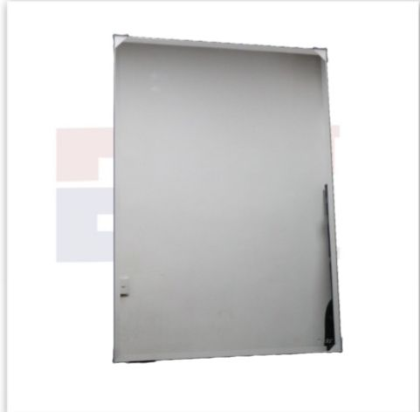

- Paper Towel Dispenser – Rs.9,500/=
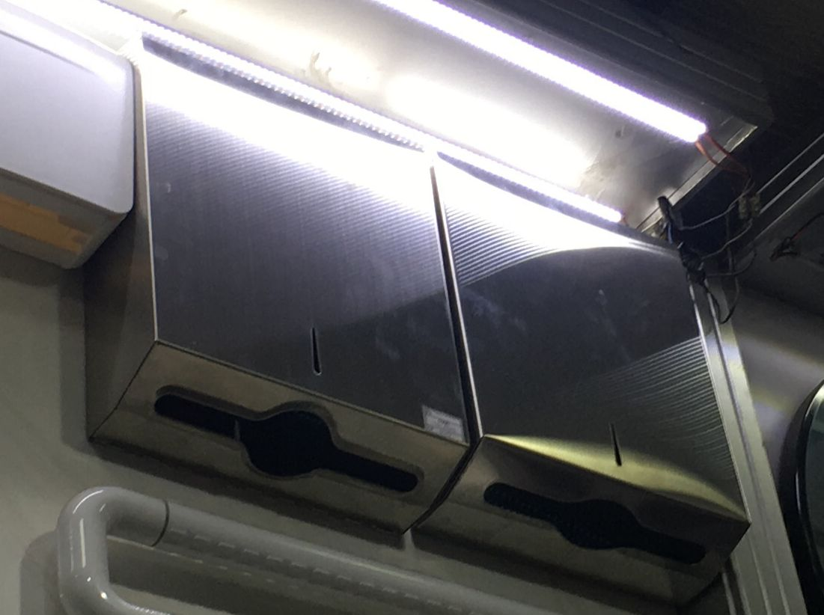

- Shower – Rs.1,750/=
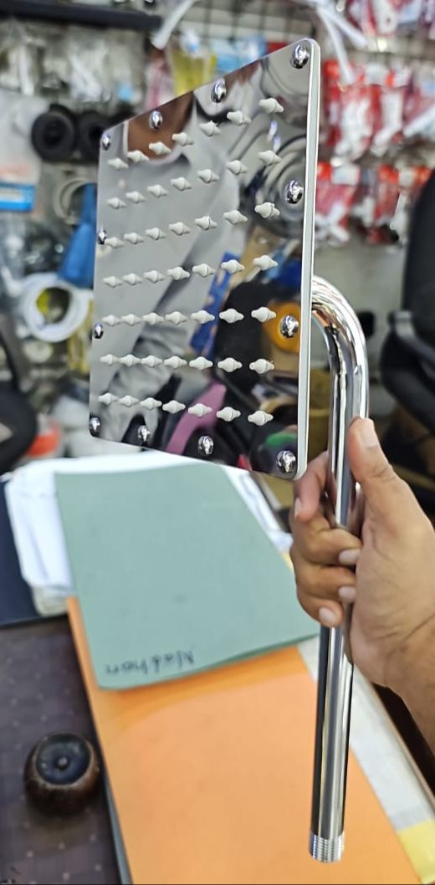

- Urinal & Wash Basin Trap – Rs.3,700/=
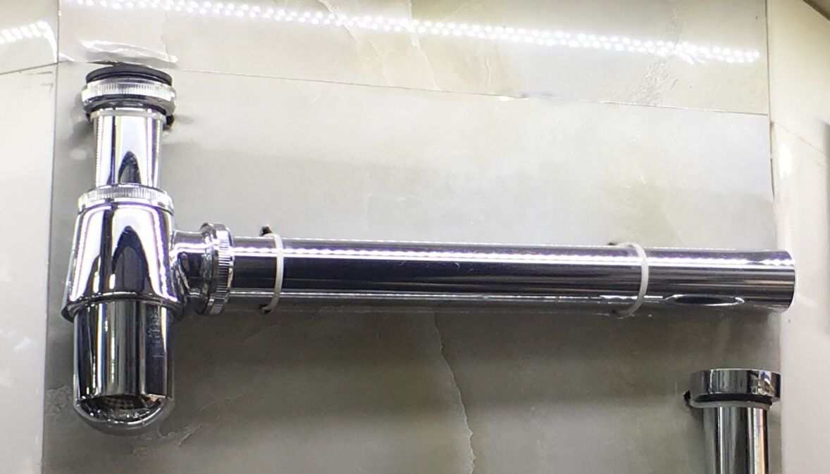

Taps From M/s Glamour
- Angle Valve Mini – Rs.3,420/= Not Preferred
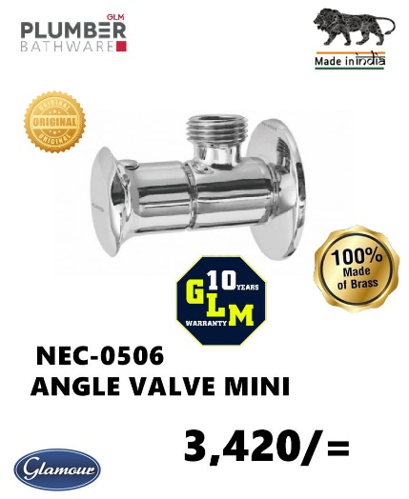

- Angle Valve – Rs.3,720/= This one preferred
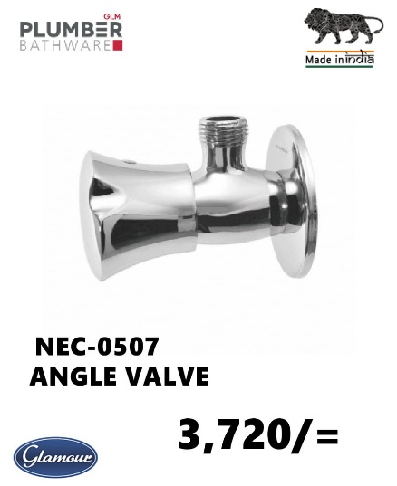

- ½” Pillar Cock – Rs.5,950/= If a longer one available please buy that

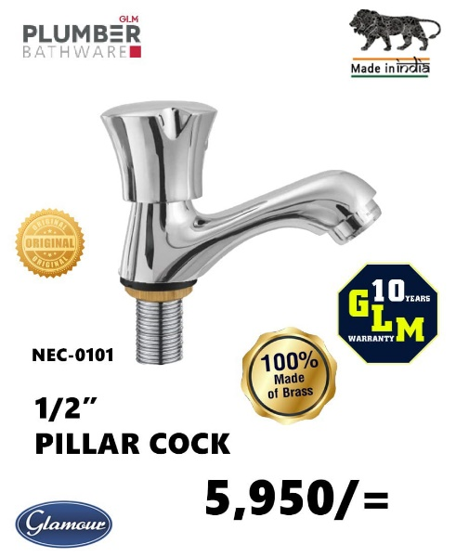

- Bib Cock
